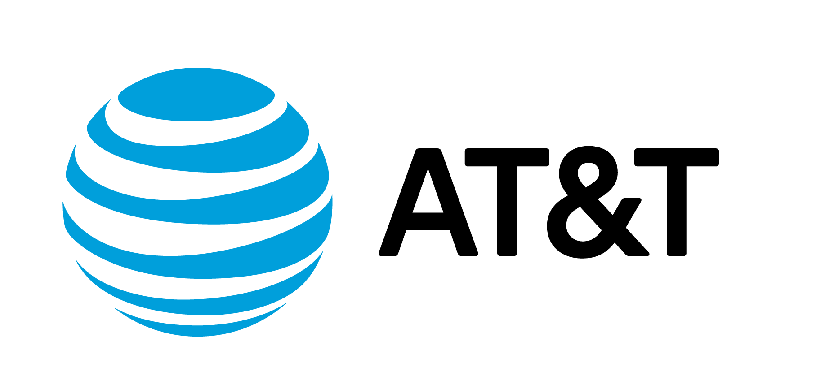

AT&T and Human-I-T Provide 100 Laptops to Local Montana Students

HELENA, Mont. – Aug. 9, 2023

What’s the news? More than 100 refurbished laptops will be given to students and families across Montana as part of AT&T’s nationwide commitment to help bridge the digital divide. The laptops, funded by an AT&T donation to Human IT will be given to 50 local Helena students in need. AT&T is working with Human-I-T and the Montana Chamber of Commerce to provide participants of the Helena Indian Alliance and the Montana Consortium for Urban Indian Health with laptops and digital literacy resources to help them fully participate in our digital world.

Why is this important?
In rural Montana, many students don’t have digital basics at home, including access to the internet, computers or skills needed to benefit from the online world, an issue known as the digital divide.

These efforts are part of the AT&T Connected Learning initiative to help address the digital divide through internet accessibility, affordability and safe adoption.

The Helena Indian Alliance and Montana Consortium for Urban Indian Health are organizations that work throughout the state to advocate for and responsibly serve the mental, physical and social welfare of the Native American population of Montana.

Through these organizations, AT&T is helping to provide 50 laptop devices to rural and tribal K-12 students in Helena, 20 in Billings, 15 to All Nations Health Center Missoula, 10 to Great Falls Indian Health Clinic and five to Butte Native Wellness Center. These devices will help students and families as they navigate school, pursue higher education and in seeking employment.

What are people saying?
“Digital literacy opens the doors to greater opportunity for young Montanans to receive the best education possible and thrive in a good-paying job,” said Montana Gov. Greg Gianforte. “I appreciate AT&T and Human-I-T for their work to bridge the technology divide and empower students in our rural and tribal communities.”

“Access to digital technology and connectivity is essential for our students to learn and to become part of a successful and skilled workforce in Montana,” said Todd O’Hair, President and CEO of Montana Chamber of Commerce. “It’s an honor to work with AT&T and our community leaders to help provide the tools and resources needed so that more students in Montana can succeed today and well into the future.”
“Let us put our minds together and see what life we can make for our children,” said Sitting Bull. Or in Lakota: Tȟatȟáŋka Íyotake.
“Helena Indian Alliance is happy to collaborate with AT&T and Human-I-T to provide laptops to our youth who will directly benefit from this collaboration,” said Linda Kinsey, Director of the Native Connections Grant, Helena Indian Alliance. “The students will benefit by being able to complete schoolwork, have access to educational and employment resources, telehealth and social connections.”
“AT&T’s contribution of laptops to our Native youth is leveling the educational playing field,” said Jason Smith, Executive Director, Montana Consortium for Urban Indian Health.
“Montana families rely on technology now more than ever,” said Misty Ann Giles, Director, Montana Department of Administration. “From education to social connection, life happens online, and we are committed to helping students stay connected.”
“AT&T is proud to collaborate with organizations like Helena Indian Alliance, the Montana Consortium for Urban Indian Health and Human I-T to help close the digital gap in underserved areas across Montana,” said Tara Thue, State President, AT&T Mountain West States. “Access to connectivity is vital in helping to bridge the digital divide and we are honored to work with community leaders to provide these resources to families and students that need them most.”

*About The Helena Indian Alliance
The Helena Indian Alliance exists to advocate for and to responsibly serve the mental, physical, spiritual, and social welfare of the Native American population and the Helena community.

*About The Montana Chamber of Commerce
The Montana Chamber of Commerce’s mission is to create and sustain an optimal business climate, business prosperity and a strong Montana economy. The Montana Chamber of Commerce, through advocacy, education and collaboration, works to provide an empowered and educated workforce, reduce business growth obstacles and advance positions that promote success for Montana businesses.

*About Philanthropy & Social Innovation at AT&T
We’re committed to advancing education, creating opportunities, strengthening communities, and improving lives. As part of our companywide $2 billion commitment from 2021- 2023 to address the digital divide, we launched AT&T Connected Learning to invest in connectivity and technology, digital literacy, and education solutions to help today’s learners succeed inside and outside of the classroom. Since 2008 we’ve committed to programs that help millions of students across all 50 states, Washington D.C and around the world, particularly those in underserved communities.

For more information, contact:
Suzanne Trantow
AT&T Corporate Communications
720-236-2056
ST101N@att.com

