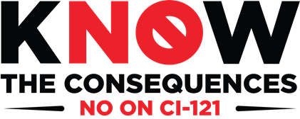
Pledge of Opposition
We Oppose CI-121 Because
We Support Hardworking Montanans.

We do not support Constitutional Initiative 121 due to the reasons below regarding the impacts it would have on our state. The costs are too steep for all hard-working Montanans, including seniors, young families, small businesses, farmers, and ranchers.

- Yes, the coalition is authorized to use my name publicly, as an opponent of CI-121.
- Yes, the coalition is authorized to use my business/organization name publicly, as an opponent of CI-121.

Printed Name Signature Date

Organization/Company Title

Address City/State Zip

Email Home Phone Cell Phone

