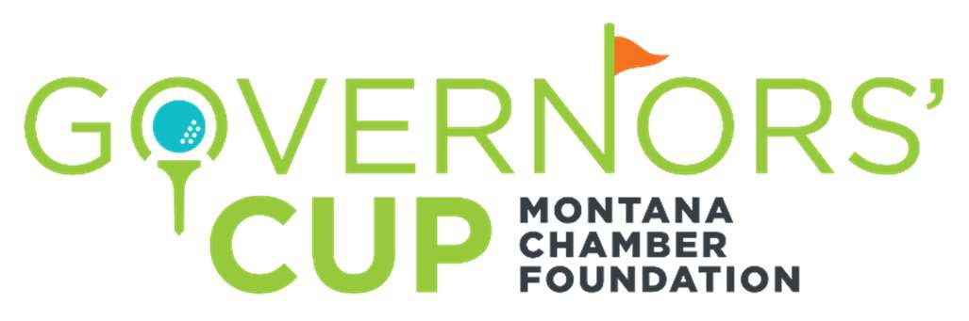
2022 Tournament Team and Sponsorship Registration Form
July 28 - 30, 2022

The Montana Chamber Foundation welcomes you to the 2022 Governors’ Cup Golf Tournament, hosted by Northern Pines, Meadow Lake and Buffalo Hill golf courses. We invite you to review our team and sponsorship options and participate in this premier event. Participation in 2022 will be limited to 81 teams.
Proceeds from the tournament support the mission and programs of the Montana Chamber Foundation.
For more information visit https://www.montanachamber.com/events/governors-cup/

TEAM/SPONSOR LEVELS | AMOUNT | TEAM GOLFERS | INDIVIDUAL GOLFERS | SIGNAGE | RECEPTION TENT
Golf Team Sponsor | $4,300 | 5 | 0
Sponsorship Opportunities  (See below link) | $1,500 to $5,000 | 0 | 0 | Varies | Varies
Individual Golfer | $1,500 | 0 | 1
https://www.montanachamber.com/wp-content/uploads/2021/11/22GC-Sandbaggers-and-Sponsorship-1.pdf

Each golfer registration includes 2 tickets to the Reception/Dinner, 2 days of golf, carts, refreshments, continental breakfasts, lunches, closing reception, tee prizes, course prizes and awards.

Please complete this registration form and return by email to efbartlett@charter.net or by mail to the Montana Chamber Foundation, PO Box 1162, Helena MT 59624. Please make checks payable to the Montana Chamber Foundation, a 501(c)(3) entity, TAX ID 23-7059679.

Team/Company Name: _Team or Sponsorship Level: Contact/Team Captain Name: Phone: Email: Address:
City/State:
Accounting or Administrative Contact (if different than above)

Name:

E-mail: Phone:

For questions or additional information contact Ed Bartlett (efbartlett@charter.net or 406.431.6014)

