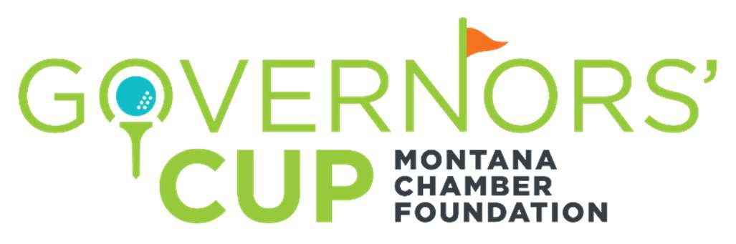
2021 Tournament Registration Form
July 29 - 31, 2021

The Montana Chamber Foundation welcomes you to the 2021 Governors’ Cup Golf Tournament, hosted by Eagle Bend, Meadow Lake and Buffalo Hill golf courses. We invite you to review our team and sponsorship options and participate in this premier event. Proceeds from the tournament support the mission and programs of the Montana Chamber Foundation. For more information visit https://www.montanachamber.com/events/governors-cup-golf-tournament/.

TEAM/SPONSOR LEVELS |  | TEAM  GOLFERS | GUEST  GOLFERS | HOLE SPONSOR  SIGNAGE | RECEPTION  TENT
Par Level Team | $3,000 | 4 | 0 | — | —
Birdie Level Team | $4,300 | 4 | 1 |  | —
Eagle Level Team | $5,800 | 4 | 2 |  | —
Guest Golfer Sponsor | $1,500 | 0 | 1 |  | —
Governors’ Circle Sponsor | $2,500 | 0 | 1

Each golfer registration includes 2 tickets to the Reception/BBQ, 2 days of golf, carts, refreshments, continental breakfasts, lunches, closing reception, tee prizes, course prizes and awards. Reception tent includes 2 tickets, a 10x10 display tent and display table for the Reception/BBQ.

To secure your space for the 2021 Tournament, please complete this registration form and return by email to efbartlett@charter.net or by mail to the Montana Chamber Foundation, PO Box 1162, Helena MT 59624. Please make checks payable to the Montana Chamber Foundation, a 501(c)(3) entity,
TAX ID 23-7059679.

Team/Company Name: _Participation Level: Contact/Team Captain Name: Phone: Email: Address:

Accounting or Administrative Contact (if different than above)

Name:

E-mail: Phone:

For questions or additional information contact Ed Bartlett (efbartlett@charter.net or 406.431.6014)

